**Report on Activities Conducted by the IT Association**

Introduction:

The IT Association has been actively engaged in organizing various events and activities aimed at fostering a sense of community, academic growth, and professional development among the students and alumni. This report provides a detailed overview of the activities conducted by the association from November 2023 to February 2024.

1. Inauguration of IT Association (14th Nov 2023):

The IT Association was officially inaugurated on November 14th, 2023. The ceremony was graced by Dr. Sangeetha U., Head of the IT department, who inaugurated the association. This event marked the beginning of our journey towards promoting collaboration and innovation within the IT community.

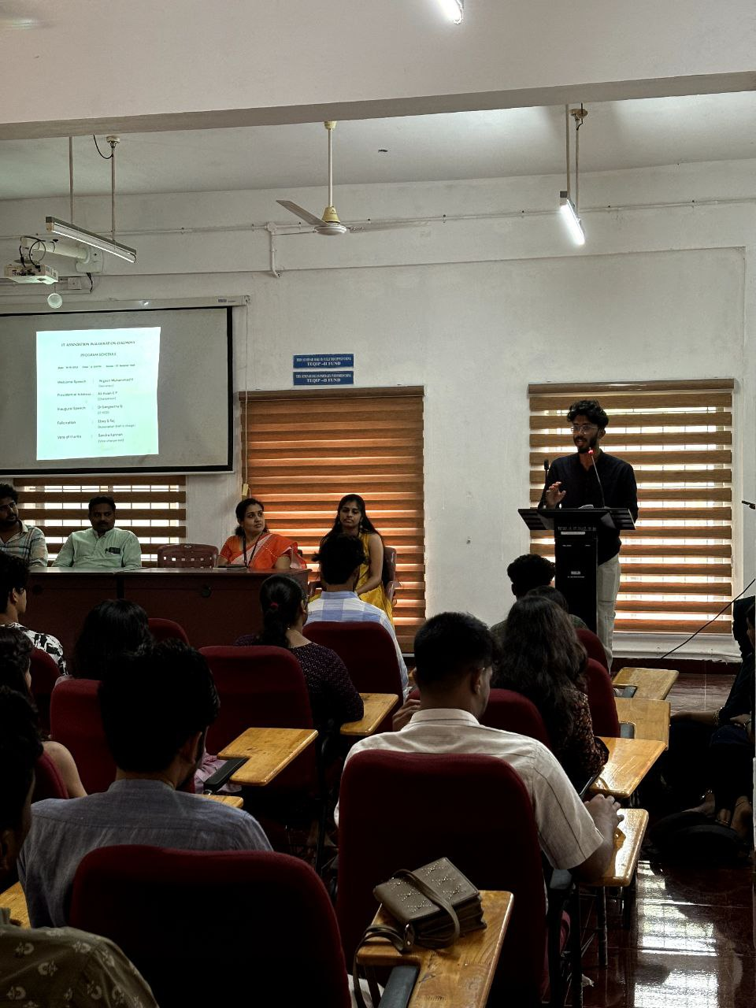

2. Christmas and New Year Celebration (20th Dec 2023):

In the spirit of the festive season, the IT Association organized a Christmas and New Year celebration on December 20th, 2023. Dr. Dhanya K.M, Associate Professor, IT department inaugurated the programme by cutting the Christmas Cake. The event brought together IT students from various batches to celebrate and cherish the joyous occasion. It served as an opportunity for students to unwind and strengthen bonds with their peers.

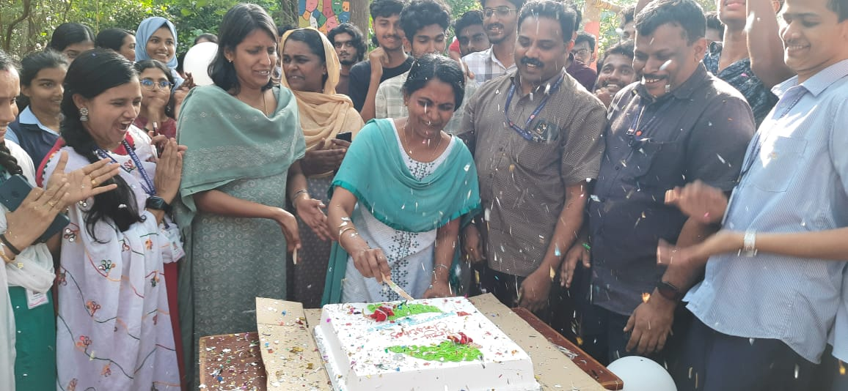

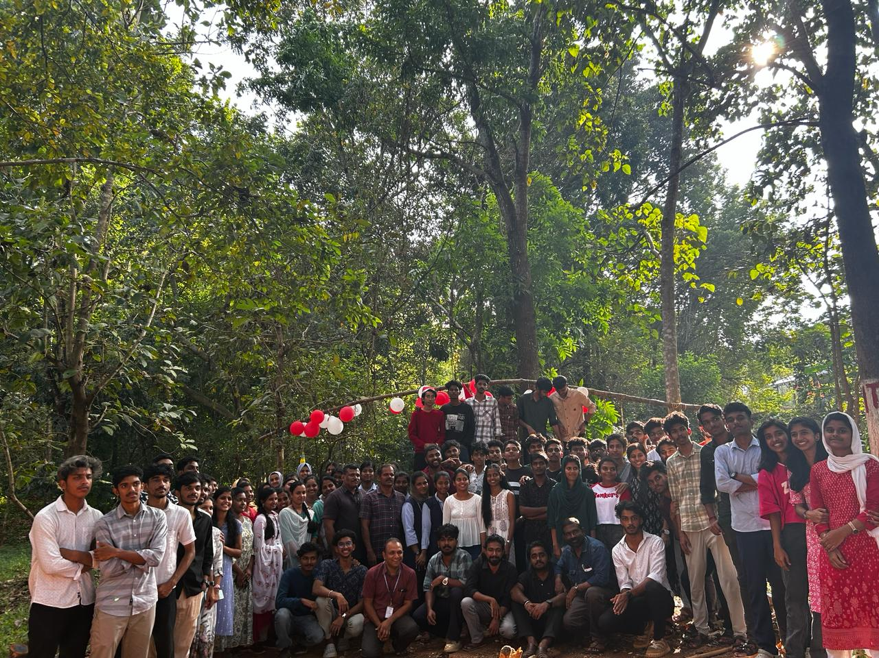

3. Interaction Programme with Alumni (29th Jan 2024):

An interaction programme with alumni was organized on January 29th, 2024, specifically targeted towards final and pre-final year students. Alumni members, Mr. Arshaque Mohammed and Ms.Angel Anto, who graduated from the 2017-21 batch, participated in the event. They shared valuable insights from their professional experiences, offering guidance and mentorship to current students. The interactive session provided a platform for students to seek advice and clarify doubts regarding career prospects and industry trends.

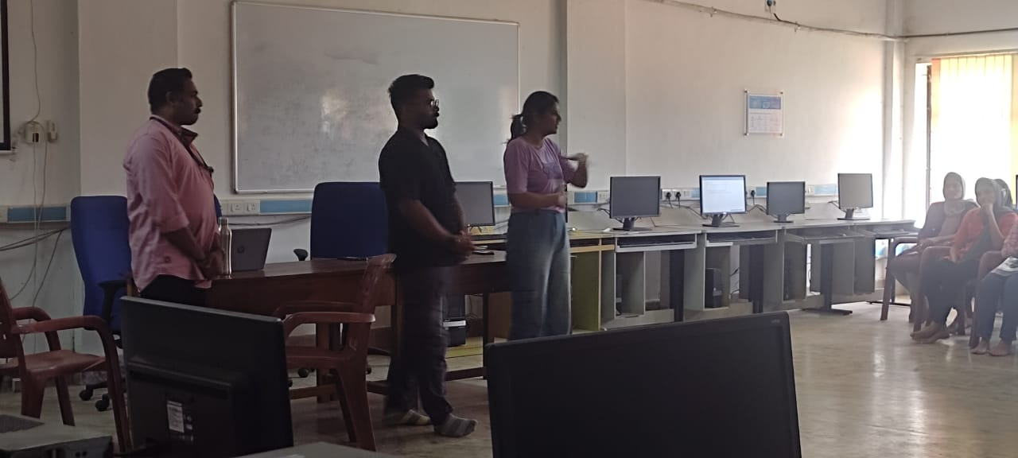

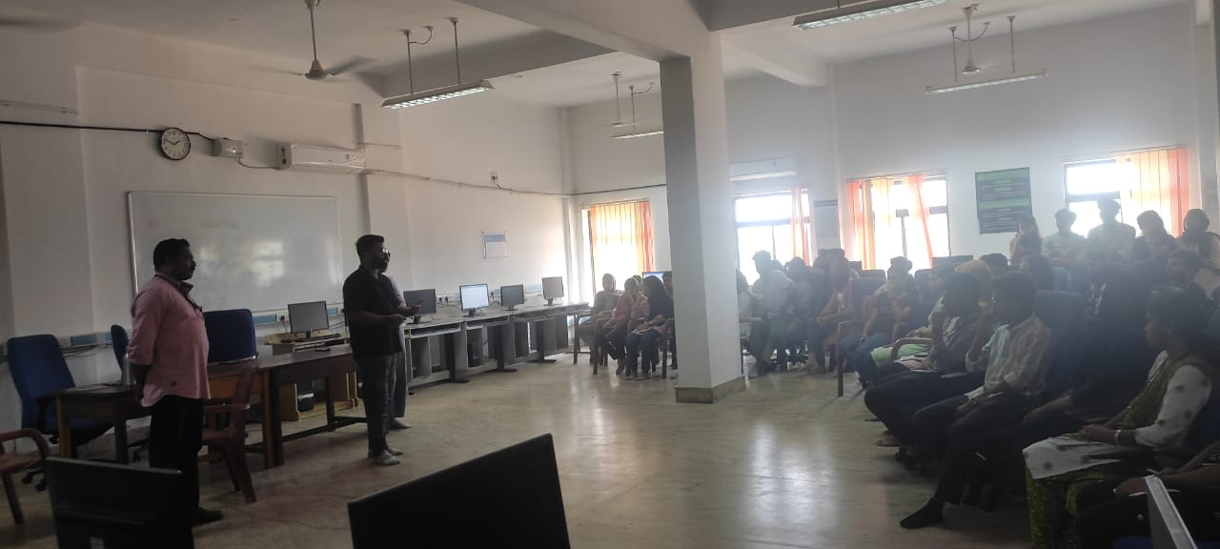

4. C-Tsunami: A regular training session of C Programming:

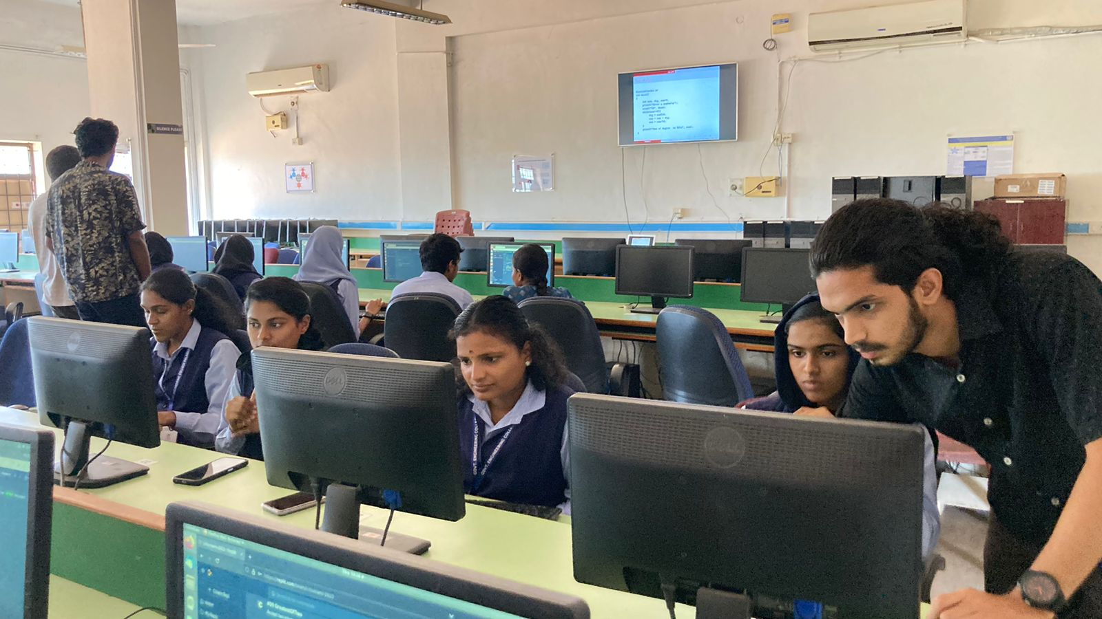

A regular training session on C programming has been initiated for students from all branches. This session, scheduled on all working days from 12:55 pm to 1:25 pm, aims to enhance students' programming skills and proficiency in the C language. Mr. Anoop S.K.M, Assistant Professor, has been appointed as the faculty in-charge of the programme. Additionally, selected students from the fourth semester IT classes are actively involved in assisting Mr. Anoop, fostering peer-to-peer learning and collaboration.

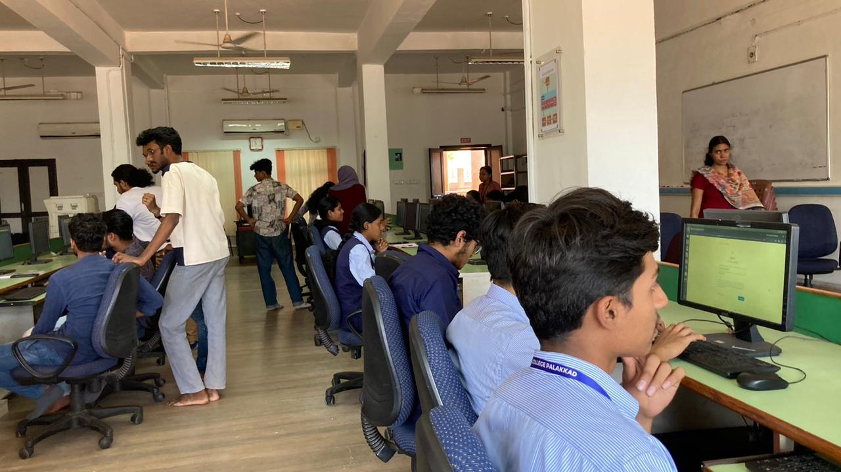

5. Programme for CSE/ IT girls

IT association and SHE cell of GECPKD is organizing a training programme on Python for all girls of IT and CSE department on March 17th 2024 from 9:30 am to 3:00 pm. Karthik A., AI Engineer, Litmus7, Kochi will handle the session.

Conclusion:

The activities conducted by the IT Association have been instrumental in promoting academic excellence, professional growth, and community engagement among students and alumni. These initiatives have not only enriched the educational experience of students but also provided them with valuable networking opportunities and real-world insights into the IT industry. Moving forward, the association remains committed to organizing meaningful events and activities that contribute to the holistic development of its members.

This concludes the report on the activities conducted by the IT Association. Should you require any further information or assistance, please feel free to contact us.

Sincerely,

Ebey S. Raj

Staff in-charge

IT Association